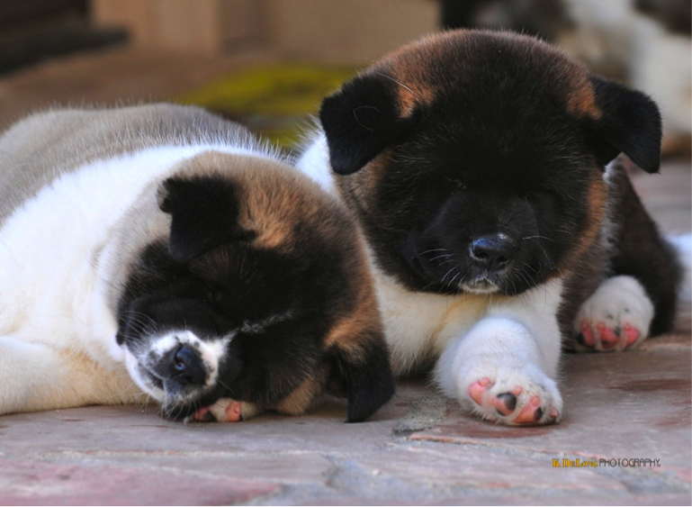

NAME:

ADDRESS:

CITY/STATE/ZIP:

EMAIL ADDRESS:

**SUNDEVIL AKITAS**

PUPPY APPLICATION

Thank you for taking the time to answer a few of our questions.

These questions will help us to meet your needs.

PHONE NUMBERS

HOME:

CELL:

How were you referred to us?

For what purpose are you purchasing an Akita?

Are you interested in a male _____ female _____ or undecided _____?

Regular coat _____ or long coat ______ or it doesn’t matter ______?

Do you have experience with dogs? With Akitas? Are they altered or intact? Where did you acquire your other Akita(s)?

How will your Akita spend its time? What provisions have you made for the care of your Akita? In other words, if you work 8-10 hours a day, will your Akita be alone in the back yard?

 Do you own other animals that will have to co-exist with your Akita? If so, what breed? Gender? Age? Temperament?

 Do you have children? If yes, how many and their ages? Are the children dog trained?

What activities do you plan to participate in with your Akita, e.g. conformation events, obedience events, agility, etc.?

Akitas can be dog-aggressive. What is your idea of proper dog and human socialization?

How many hours a day do you have to spend with this/train this animal (don't count sleeping hours)?

Have you ever taken your puppy/dog to Obedience Training? Are you willing to take this puppy/dog to both Puppy Training & Obedience Training?

Have you ever Crate Trained a puppy/dog? Are you willing to Crate Train you new puppy/dog?

Do you have a fenced yard? What kind of fencing and how high? How big is your yard? Is there adequate shelter for the Akita to escape the sun and the cold? Describe and provide photos with fencing visible.

Will you allow an in-home visit before placement of a puppy?

Have you ever bred a litter of puppies? If yes, what breed and how many litters?

Some homeowners insurance companies will not insure a home with an Akita; do you know what your policy requirements are?

  Please provide three references: (Veterinarian, friend, breeder, relative, etc.) Include phone numbers.

Who will care for your Akita when you go out of town? Will your Akita be boarded frequently?

Rate the following Akita qualities in your own order of importance (1 being most important, etc.):

Color Size

Temperament Akita "look"

Health

Owning an Akita means making a commitment to its health, happiness and well-being for 10 to 13 years, its average life span. Are you ready to make this kind of long-term commitment?

**Did you know that...** (Please answer with **Y or N**)

Akitas cannot ever be off leash in an open area (such as a park, street, unfenced yard)?

Akitas are dog aggressive and normally do not get along with a dog of the same sex?

Akitas have a strong prey drive and can hurt small animals such as cats, birds or other

small dogs?

Akitas should not be tied out in the yard?

Akitas are naturally dominant and need to go to obedience training with their owner?

Are you prepared to sign and honor a breeder contract that stipulates neutering/spaying of your Akita when age appropriate (usually twelve months or older)?

Are you aware that the registration papers accompanying your Akita are "limited?" That means that if you should breed this dog, the offspring are not eligible to be AKC registered.

Are you prepared to sign a breeder contract that requires you to return the dog, without financial compensation, to the breeder should your circumstances change and,

FOR WHATEVER REASON, you can no longer keep the Akita?

*The information I have provided in this document is correct and true to the best of my knowledge and I have not withheld any pertinent information. I understand that any misrepresentation of me or my family or any untruths in the information provided herein will invalidate any or all agreements and will give us the right to recover the Akita without your permission and without a refund. Submittal of this form provides my agreement to this application.*

_______________________________________________ _____________________

Signature : Date :